How to change the Wi-Fi name (SSID) and wireless password
Model number: FH303
If you want to manifest personality and protect your wireless network, you can follow this article to set a special Wi-Fi name and wireless password.
Part 1: Login the homepage of the router
Part 2: Change the SSID and wireless password
Part 3: Reboot the router
Open a browser then type 192.168.0.1 in the address bar, click “Enter”.
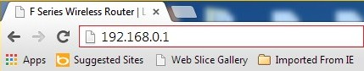
Note: if you can’t login the home page, please click HERE.
1 Fill in admin in Password fields, click OK to login.
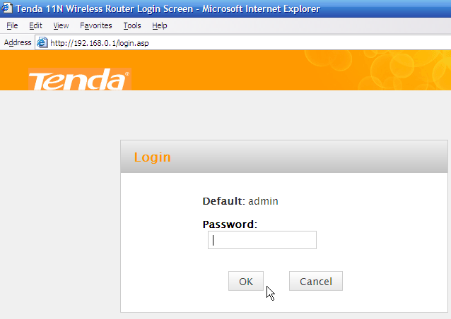
2 Click Advanced on the home page to login the advanced setting page.
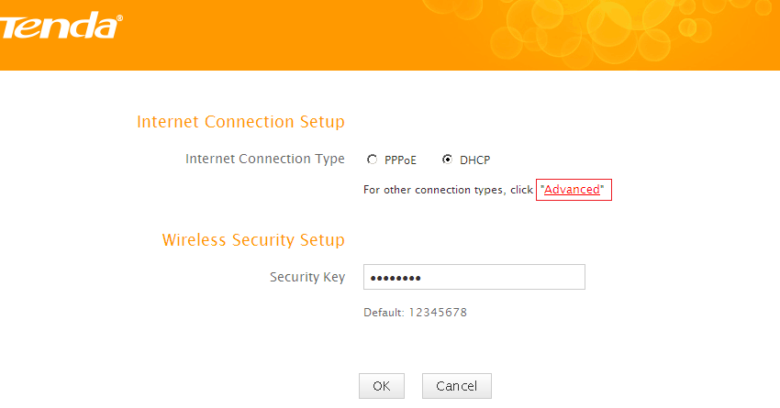

3 Click Wireless, then click Wireless Basic Security, making sure Enable Wireless and SSID Broadcast were checked. Also you can change the Primary SSID as you want, then click OK to save the settings.
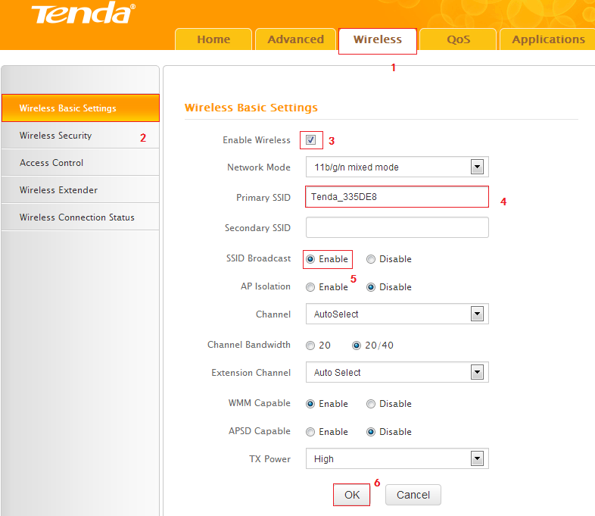
Note:
I: the Channel 1, Channel 6 and Channel 11 are recommended, since there are a little interference.
4 Click Wireless, then click Security and choose the Security mode as WPA-PSK, set a Security Key as you want. At last, let the other options as default and hit OK to save the settings.
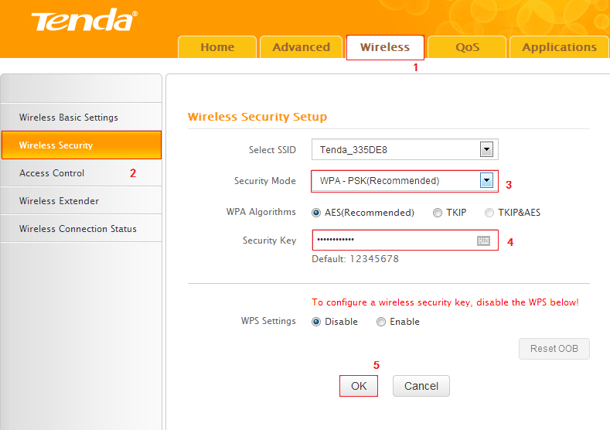
Note: Security Key should be at least 8 characters.
Click Tools, and then choose the Reboot option on the left of the page, then hit Reboot The Router and OK to refresh the device info.
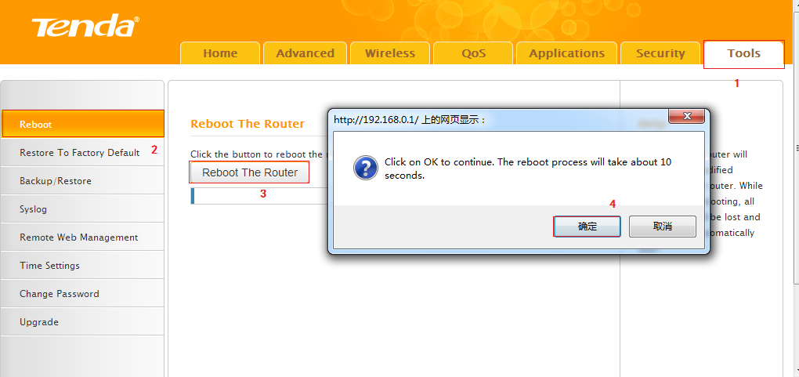
Congratulations! You can enjoy your wireless network with new Wi-Fi name and new password.
Note: if you do not know how to connect your Wi-Fi please click HERE.

